* Subscribe Newsletter : Change section to form

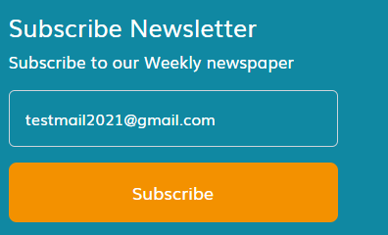

* Change email and phone to link by use meta data to allow user call or send email direct



* Change color for hover in second button and add hover to first button, Please check all buttons in About Course page, need enhancement

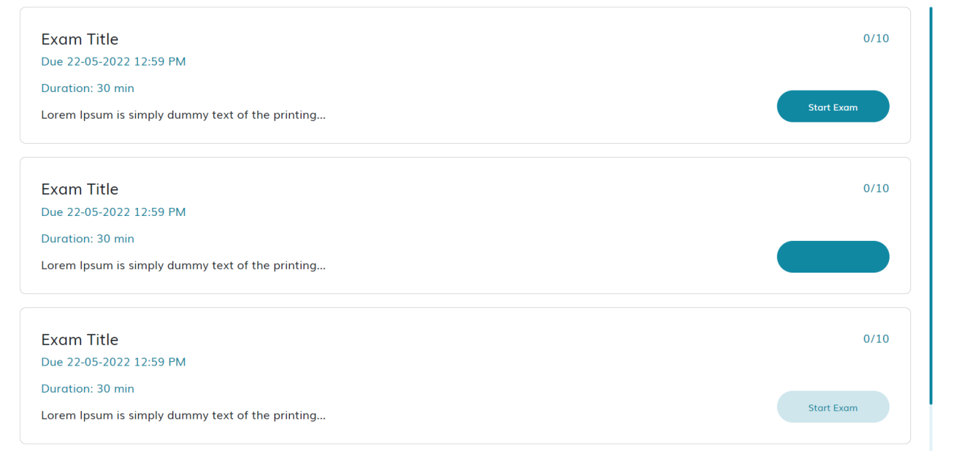

* Fix all errors in console by inspect element in browser
* Change filter in blog page to form ( change forms for these pages (Courses , Change Your Password , Check Your Email , Our Team, password – User profile ,

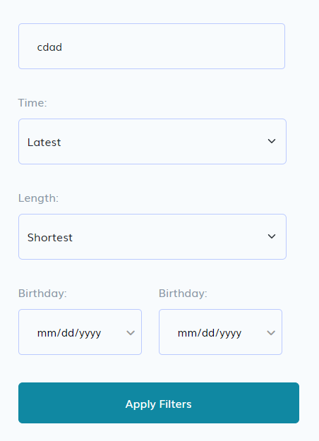

* Change filters to froms and enhancement hover for export button ( Calender page)

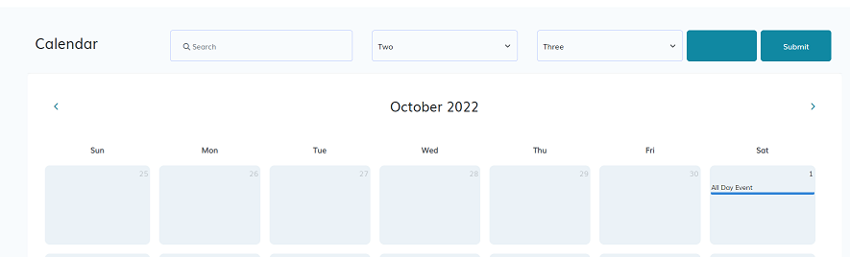

* Change category name to link

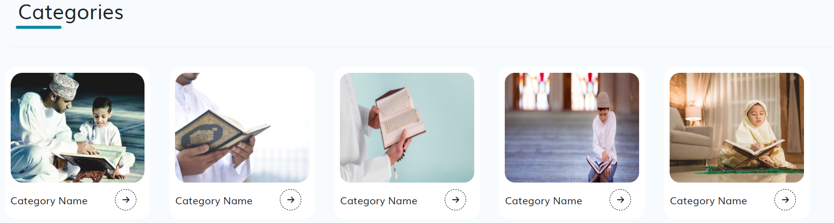

* Change eye icon when click to show password , and change div to form

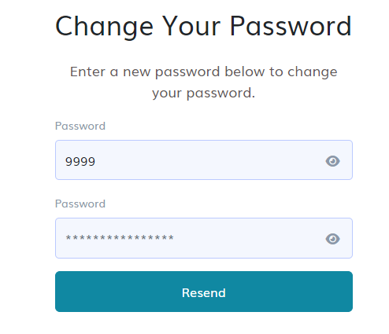

* Add tel, email , location tag to allow user clickable it (Contact us )

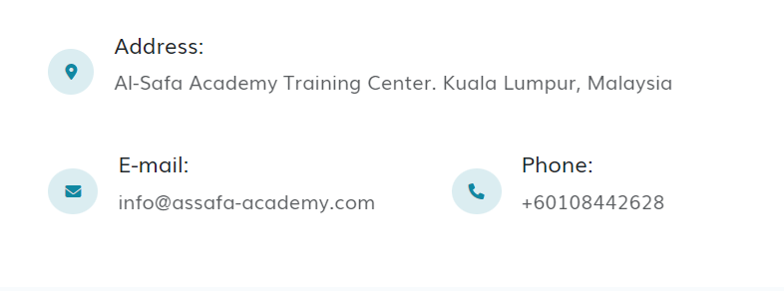

* Change buttons to link in slider

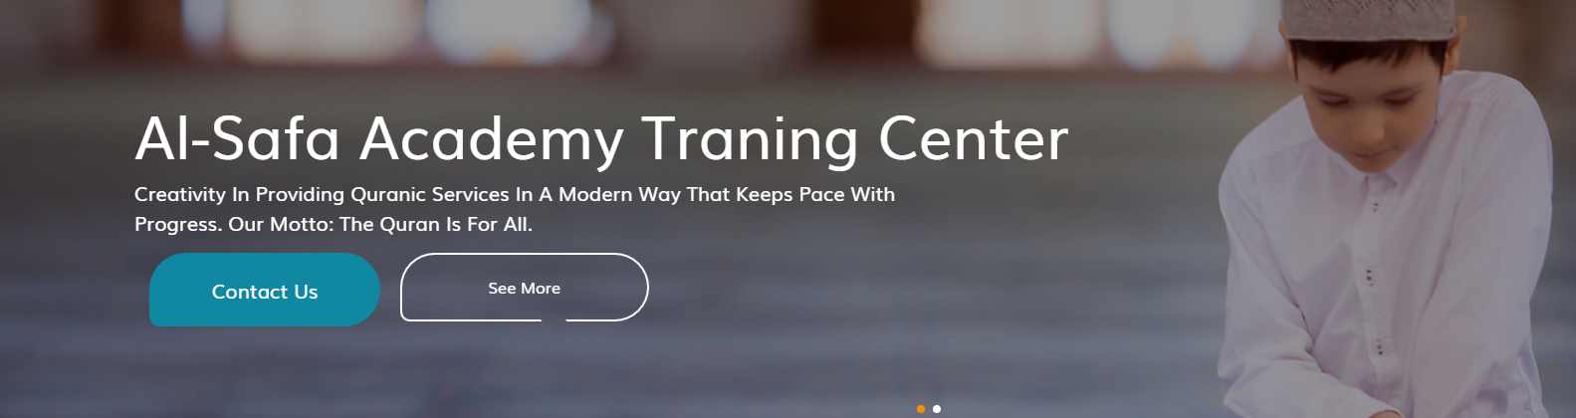

* Add message error to form after submit

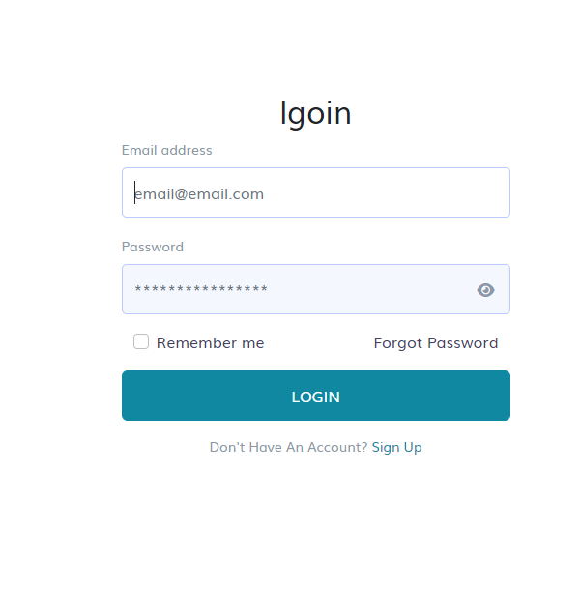

* Slider not working

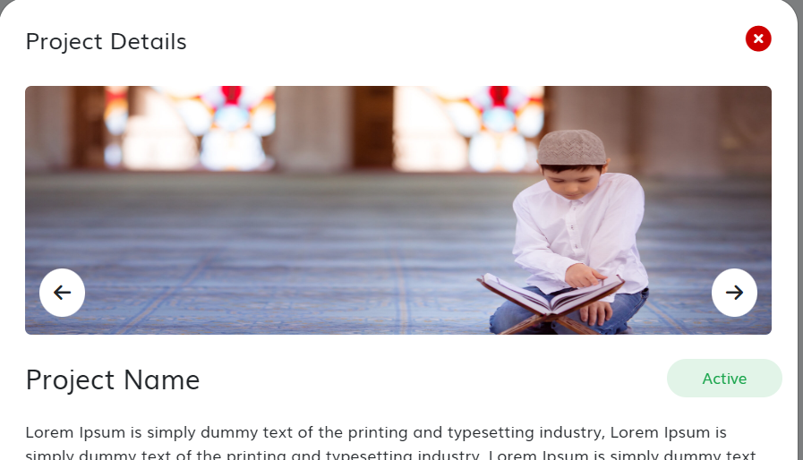

* Change to form , add vaildation to match new passowrd and repeat new password

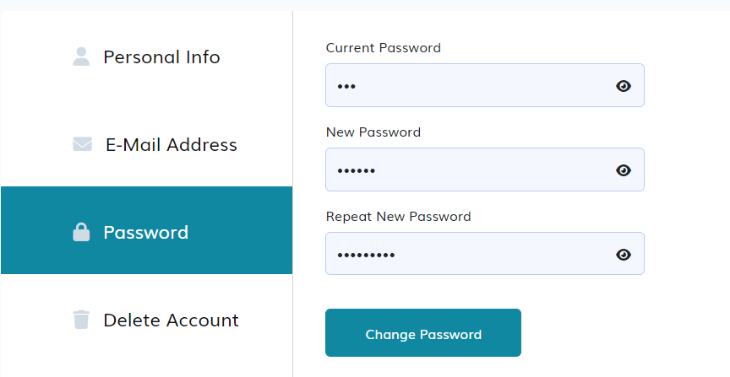

* Change buttons to links in Certificates – User profile
* Calender in User Profile not working

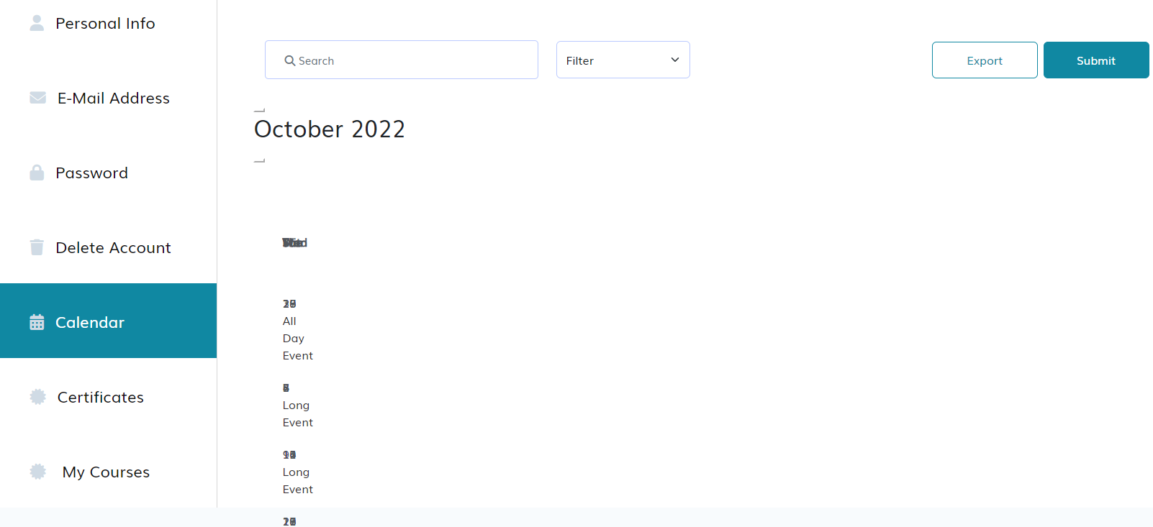

* Add alters , message for forms when faild/ success request
* Responsive desgin

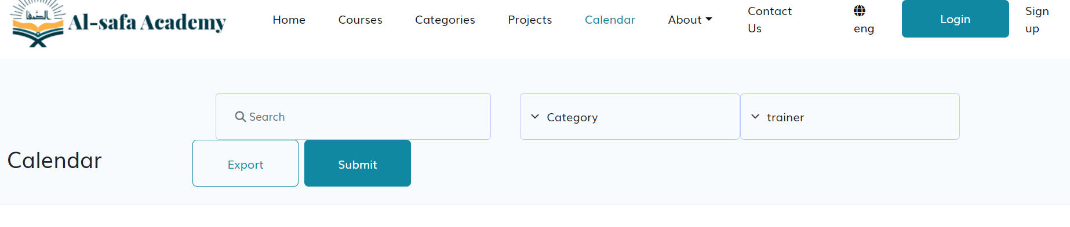

* In arabic style – ehancement icns in home page

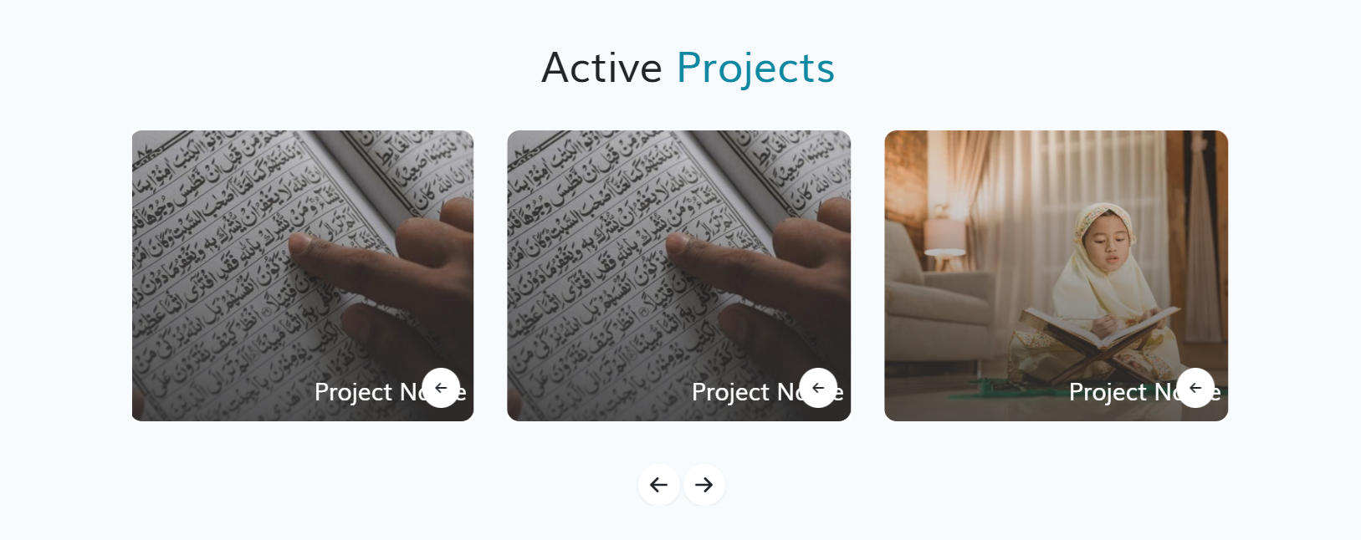

* Change design to RTL ( Contact us , Calender , Active Projects)

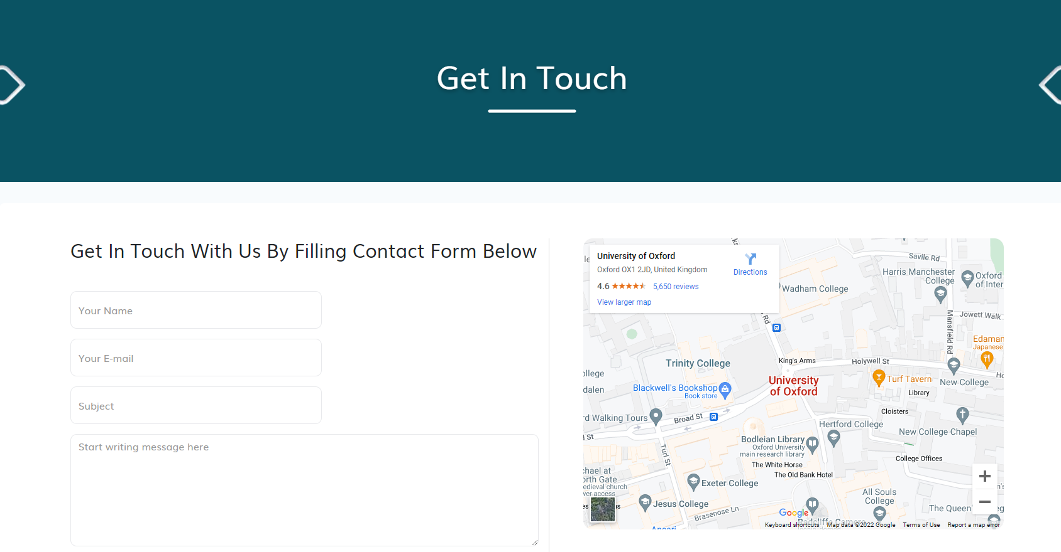

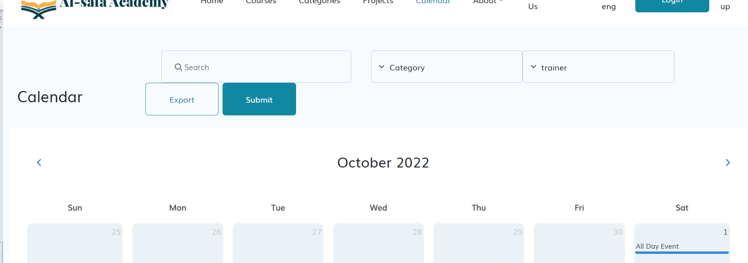

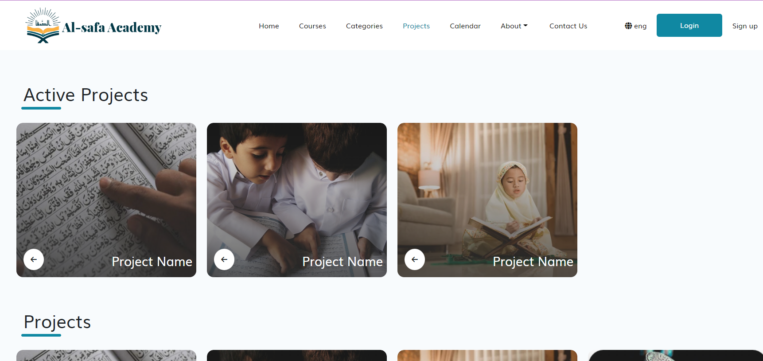

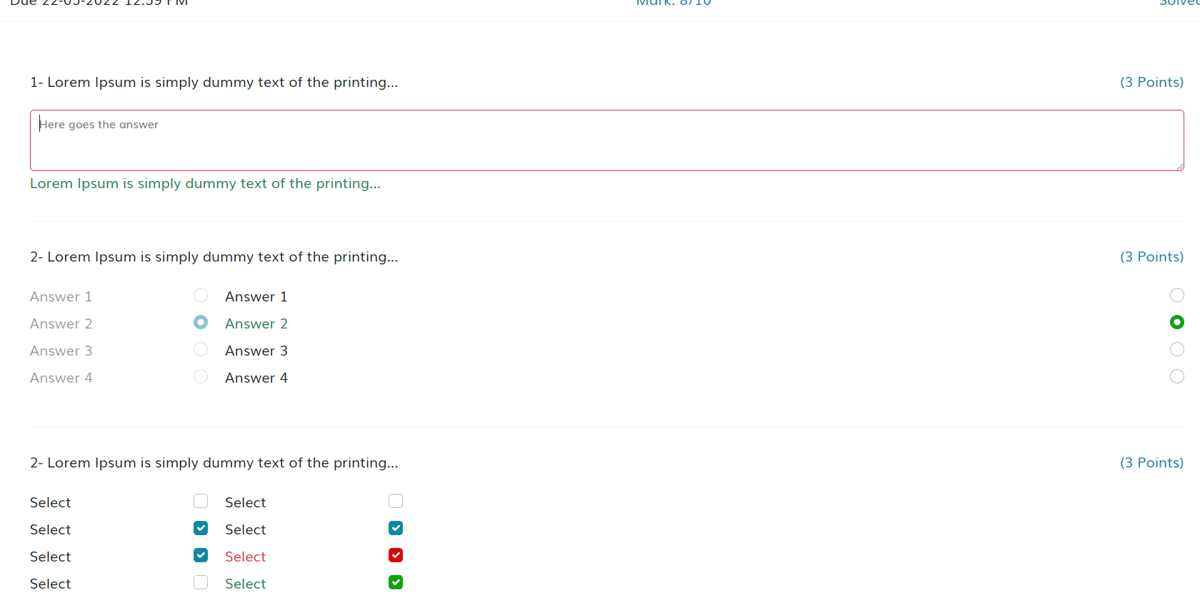

* In Mobile : some title in tabs not display – About Course

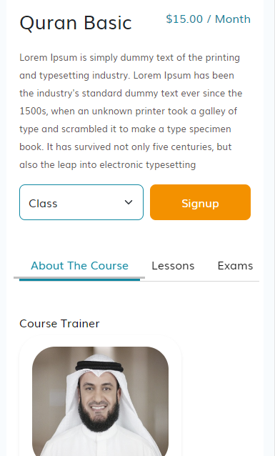

* Add Margin to right side of page in Categories

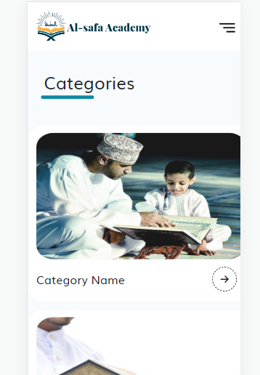

* Ehancement (Get in Touch,Our Courses,Exam,Project Destails, Active Project,Our Team , Trainer Details , User Profile ) to prevent move right – left

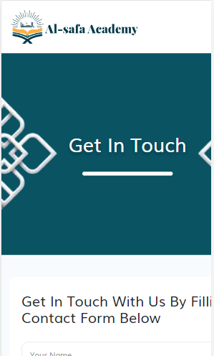

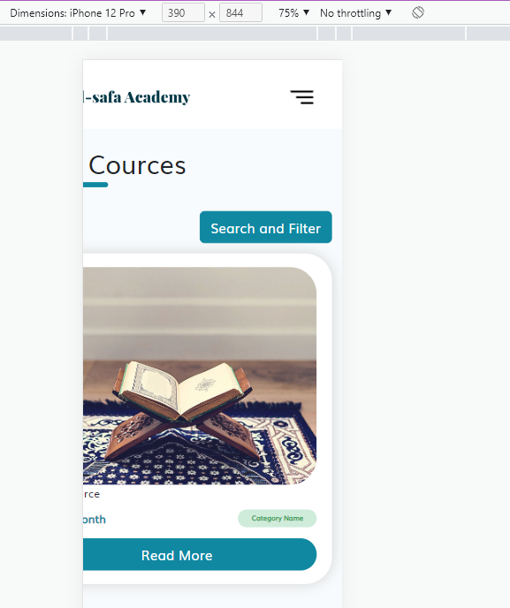 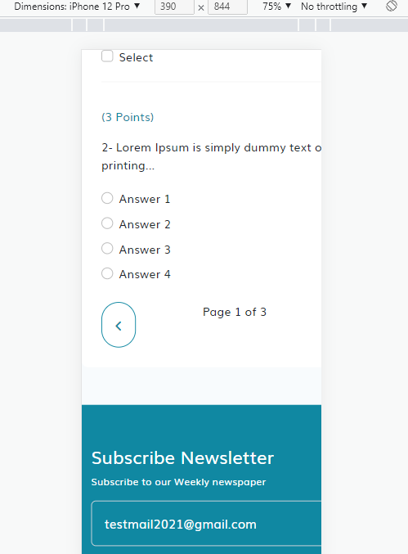

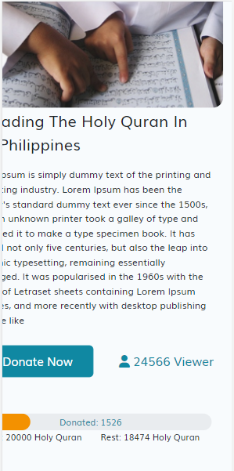 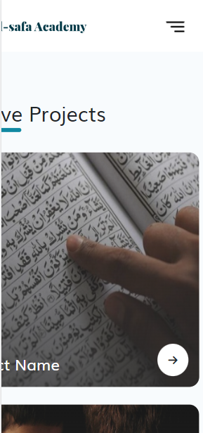

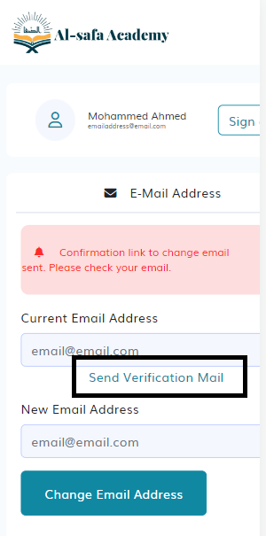 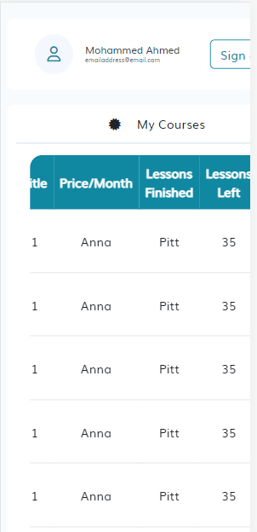

**My Display Resoulation**

